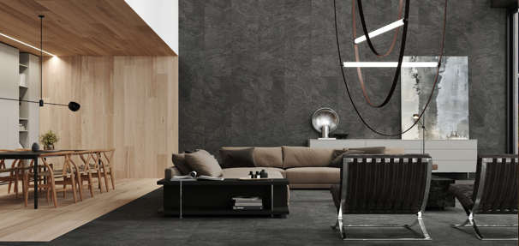

Tile collection: RAKO INNOVATIONS for 2025
Plzeň, March 2025. With its collection for 2025, RAKO is launching a wealth of new products. This year, a total of 11 new series will be added to the portfolio of the Czech tile specialist, which is part of the Lasselsberger Group. Seven of these (CRAFT, DALE, FLY, TOUCH, SHADE, PLANK and BLOSSOM) are available as indoor tiles, while four others (CORE, MIXTONE, RAVE and PINO) are available as both indoor and outdoor tiles. RAKO is consequently following the trend of designing and connecting indoor and outdoor spaces in a fluid way.
The RAKO innovations 2025 in a nutshell:
- Core: A series with an authentic slate look, a wide range of designs, and many formats for indoor and outdoor use
- Craft: The successful combination of classic style and modern elements in tiles with warm shades of chamotte and fired clay
- Dale: Simplicity, elegance and functionality for bathrooms and living areas with the modern look of a cement filler in the colours white grey, grey, dark grey and beige
- Fly: Finely contrasting white lines run through the surface in a random pattern - almost like the condensation trails of aeroplanes in the sky
- Mixtone: A tile with a natural stone look that captures the essence thereof with impressive precision and blends harmoniously with any interior or exterior
- Touch: A luxurious look inspired by marble from a quarry near Santa Magdalena de Pulpis, available in four carefully selected shades.
- Rave: Reminiscent of the decorative Italian ornamental stone Ceppo di Gré, an indoor and outdoor tile series that is reminiscent of terrazzo and preserves the beauty of natural stone for the future.
- Shade: Elegant naturalness with subtle shades that authentically reproduce the famous bluestone. Accessories such as mosaics complete the harmonious aesthetic.
- Plank: Floor tiles with a Scandinavian-style wood decor - in plank format and stylishly complemented by a wall tile with a mosaic look in a matt-gloss combination.
- Pino: A range of tiles for indoor and outdoor use. So perfect that it is almost indistinguishable from real wood, Pino guarantees comfort and timeless aesthetics.
- Blossom: A sea of flowers and colours that seems to break through the wall to bring nature into the room.
CORE: Combining natural aesthetics with modern functionality

The CORE range is presented with an authentic slate look, and with its irregular surface structure is a perfect alternative to natural stone. Responding to market and customer demand for natural surfaces, CORE is a long-awaited addition to the RAKO range.

The nature-inspired relief and the wide variety of designs of the tiles expand the design possibilities for upscale interiors. Thanks to its flexible formats (60 x 120, 60 x 60, 30 x 60, 10 x 10 and 5 x 5 cm) and complementary technical accessories, CORE can be used in the residential, commercial, hotel and retail sectors. The R10/B (ABS) surface is ideal for safe indoor use, while the 30 x 60 cm format with the R11/C surface is the perfect choice for wet areas, swimming pools and pool complexes. CORE is the perfect tile for those who want to combine natural beauty with modern functionality.

For high quality outdoor areas, CORE OUTDOOR offers matching tiles in 60 x 120 x 2 cm and 60 x 60 x 2 cm formats, colour-coordinated with the indoor collection. This allows for a harmonious transition between indoor and outdoor areas - including matching step tiles.

CORE tile sizes:
60 x 120, 60 x 60, 30 x 60,
10 x 10, 5 x 5 cm
CORE outdoor sizes:
60 x 120 x 2 and 60 x 60 x 2 cm

((Images: Please note copyright: RAKO, 2025))

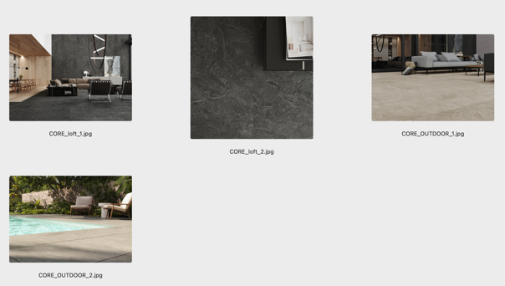
CRAFT: Classic elegance interpreted in a modern way

The CRAFT series is for those who want to escape the hustle and bustle of the city and create a comfortable living environment with classic style and modern elements. The rich colour palette and slightly aged surface give each CRAFT tile its unique character. Warm colours of chamotte and fired clay with fine small stones in the surface underline a traditional look that suggests craftsmanship and uniqueness. But while CRAFT is inspired by historical models, it is manufactured using the latest technology, which makes this natural look possible. Available in 60 x 120, 60 x 60 and 20 x 20 cm formats, CRAFT tiles combine an authentic look with the highest quality production and product.

CRAFT tile formats:
60 x 120, 60 x 60, 20 x 20 cm

((Images: Please note copyright: RAKO, 2025))

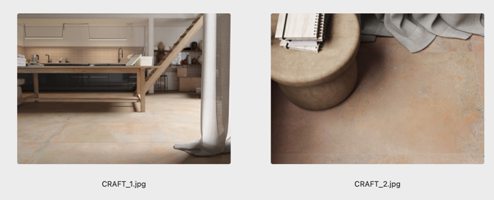

DALE: Attractive design with a cement tile look

The carefully thought-out design of the DALE tile combines simplicity, elegance and functionality, making it suitable for both private and public spaces. The new range offers the modern look and feel of a cement tile, combined with high resistance and durability - an economic and environmental advantage of ceramics over other short-lived materials. The matt surface of the wall tiles and the unglazed decorative tiles with subtle relief underline the timeless modern effect of the colours white grey, grey, dark grey and beige. They come into their own on the calibrated wall tiles in 30 x 90 and 30 x 60 cm formats and the DALE floor tiles in 60 x 120, 60 x 60 and 30 x 60 cm formats with minimal joints. The 30 x 60 and 30 x 30 cm tiles are intended for areas with increased slip resistance requirements. Their slip resistance is declared as R11/B, R12/B and R11/C for wet areas respectively.

For decorative applications in the private and public sectors, DALE is available in many combinable formats, including mosaics in 10 x 10 cm and 5 x 5 cm formats. The full range of technical accessories is also available in all colours. The series has great potential for flexible use in a wide range of projects: thanks to the excellent technical parameters, the high level of slip resistance (in all colours and formats) and the homogeneous design, both architects and investors will appreciate the technical qualities and aesthetic variability of the DALE series.

DALE tile formats:
Floor tile: 60 x 120, 60 x 60, 30 x 60, 30 x 30 cm
Wall tile: 30 x 90 and 30 x 60 cm

((Images: Please note copyright: RAKO, 2025))

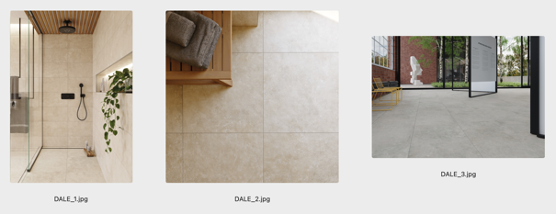

FLY: Boundless movement and elegance

The FLY tile range is ideal for creative designers, architects and builders who want to add personality and technical sophistication to their spaces. The dynamic surface effect of FLY symbolises boundless movement and freedom in the sky. Inspired by the condensation trails left by aircraft in the sky, fine contrasting white lines run through the surface in random patterns. With its timeless design, versatility and subtle colours, FLY combines aesthetics and functionality.

FLY combines the excellent technical properties of unglazed sintered ceramic tiles and offers a wide range of large-size rectified floor and wall tiles. The timeless character of the whole range is underlined by neutral colours such as light grey, dark grey, beige and brown. A matt, smooth surface with slip resistance R10/B, including 10x10 and 5x5 cm mosaic formats, skirting boards, treads and mosaics are available for a precise solution that goes beyond technical details. The advantages of the FLY series are its timeless design, its variability and its discreet colour range. All this makes it ideal for a wide range of applications, both indoors and outdoors, in both private and public spaces.

FLY tile formats:
Floor tile: 120 x 120, 60 x 120, 80 x 80,
60 x 60, 30 x 60 cm
Wall tile: 30 x 60 cm

The FLY series offers the excellent technical properties of unglazed sintered ceramic tiles in a wide range of large-size rectified floor and wall tiles. Neutral colours such as light grey, dark grey, beige and brown underline the timelessness of the whole range. A matt, smooth surface with R10/B slip resistance, including 10 x 10 and 5 x 5 cm mosaic formats. Skirting, step tiles and mosaics are available for a precise solution that goes beyond technical details. One of the advantages of the FLY series is its timeless design, its variability and its moderate colour range. All this makes it ideal for a wide range of applications, both indoors and outdoors, in both the private and public sectors.

((Images: Please note copyright: RAKO, 2025))

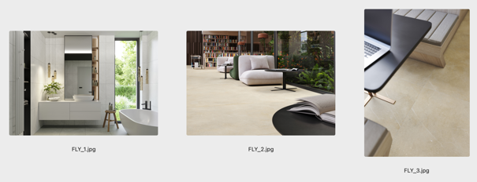

MIXTONE: An authentic natural-stone look

Thanks to the latest digital printing technology, the MIXTONE series transfers the design of large natural stone blocks to ceramic tile surfaces with impressive precision. Each tile is given a unique pattern that faithfully reproduces the natural colour nuances and variations of real stone. The random arrangement of the motifs on the large format tiles creates an organic, natural look. The carefully coordinated colour consistency of MIXTONE perfectly captures the essence of the striking natural stone and blends harmoniously into any interior.

MIXTONE is complemented by outdoor floor tiles. Thanks to its versatile design and high resistance to environmental influences, a seamless transition between home and garden can be easily achieved. RAKO's MIXTONE ceramic floor tiles combine high utility value with a natural stone look, without compromising on functionality, sustainability and quality.

MIXTONE tile formats:
60 x 120, 80 x 80, 60 x 60 cm
Mixtone outdoor formats:
60 x 120 x 2 and 60 x 60 x 2 cm

((Images: Please note copyright: RAKO, 2025))

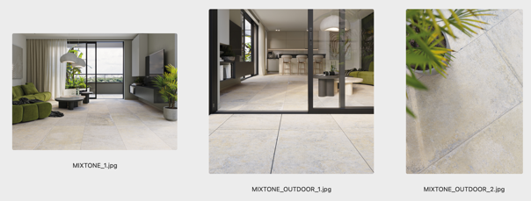

TOUCH: An exquisite finely veined marble look

TOUCH is an exclusive series of ceramic floor tiles that combines apparent luxury with timeless design. Inspired by marble from a quarry near Santa Magdalena de Pulpis, it boasts a nuanced range of colours and an impressive visual depth. Available in four carefully selected shades (two warm and two cool), it adapts flexibly to any style. Environmentally-friendly production at RAKO means that TOUCH meets modern sustainability standards and is the ideal choice for demanding projects.

TOUCH tile formats:
120 x 120, 60 x 120 and 60 x 60 cm

((Images: Please note copyright: RAKO, 2025))

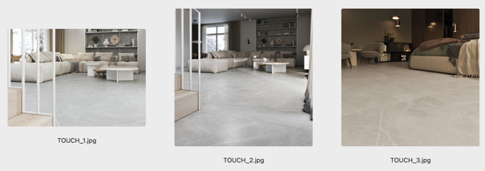

RAVE: Reminiscent of the decorative Italian ornamental stone Ceppo di Gré

RAVE is a successful example of the ability of man-made ceramics to create surprising images and emotions that otherwise only nature can evoke. "The key to a tile project is RAVE: sustainable, vital and unconventional," say the RAKO designers about their appealing creation. Inspired by the Lombardy ornamental stone Ceppo di Gré, RAVE is on the one hand reminiscent of an artificial terrazzo, but on the other preserves the original aesthetics of the historic natural stone from Italy: the irregular structure of the polished stones gives each tile its uniqueness and spatial depth. With the RAVE series, the RAKO designers have brought the classic Ceppo di Gré into the present and preserved its timeless beauty for the future.

The complexity of a design can be seen in many facets, as well as when indoor tiles meet outdoor tiles with a thickness of 2 cm. The RAVE OUTDOOR floor tiles are a successful example of the harmonious interplay between indoor and outdoor applications: Like the indoor tiles, they are available with a smooth surface and in the 60 x 60 x 2 cm format, as well as with the required R11/B slip resistance.

RAVE tile formats:
120 x 120, 60 x 120 and 60 x 60 cm
RAVE outdoor format:
60 x 60 x 2 cm

((Images: Please note copyright: RAKO, 2025))

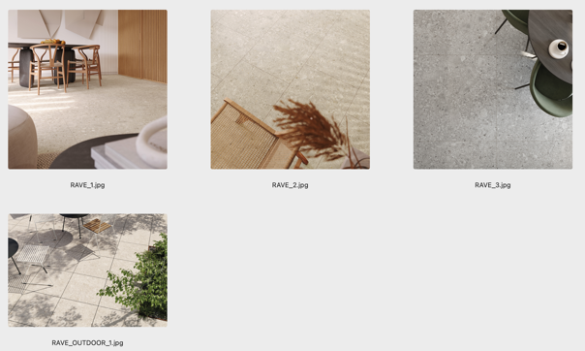

SHADE: Uncompromising in modern architecture

Combining elegant naturalness with subtle nuances, the SHADE series is an authentic reproduction of bluestone, a volcanic basalt rock. It gives floors and walls a modern and casual elegance. Its natural stone look is particularly effective in light-flooded designs, creating bright, inviting spaces. Large formats in 60 x 120 cm and 60 x 60 cm enhance the sense of space and ensure smooth transitions. Technical accessories such as mosaics fit in perfectly and enhance the harmonious aesthetics of these exceptional tiles.
SHADE tile formats:
60 x 120 cm and 60 x 60 cm

((Images: Please note copyright: RAKO, 2025))

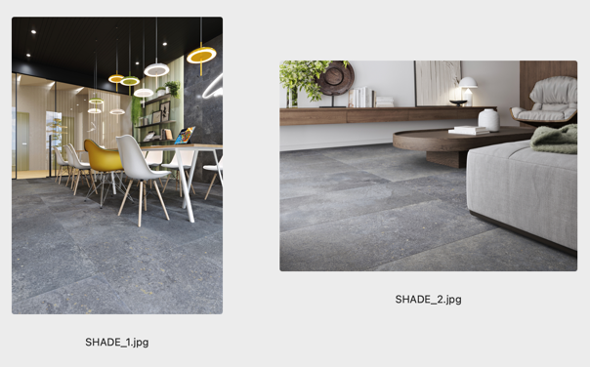

PLANK: Warmth and naturalness in Scandinavian style

Scandinavian style thrives on natural materials, soft natural colours and homely accents - and this is exactly what the PLANK series embodies. The 20 x 120 cm wood-decorated floor tile features light colours and a finely textured relief that authentically reproduces wood. It is suitable for living rooms, bedrooms, kitchens and bathrooms. PLANK is complemented by a 30 x 90 cm wall tile with a striking mosaic look in a matt-gloss combination. The durable interior tiles are water, scratch and chemical resistant. They are also perfect for floors with underfloor heating and are easy to clean.

PLANK tile formats:
Floor tile: 20 x 120 cm
Wall tile: 30 x 90 cm

((Images: Please note copyright: RAKO, 2025))

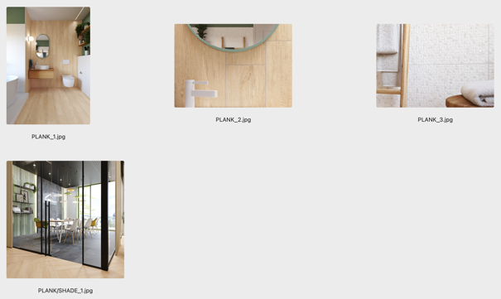

PINO: A wood look with the durability of ceramics

Thanks to its wood decor, the PINO ceramic range is visually indistinguishable from real wood. The colour and design look deceptively real, while the tiles offer the advantages of ceramic materials. The rectified 20 x 120, 20 x 80 and 5 x 5 cm formats allow a wide range of laying patterns. The range is complemented by 30 x 60 cm tiles in a light stone look with embedded small coloured stones. Ideal for underfloor heating, PINO combines performance, comfort and the timeless aesthetics of wood.

PINO OUTDOOR creates a seamless and flowing link between indoors and outdoors. The 60 x 120 cm tiles are 2 cm thick and can be laid on support plates, gravel beds and other surfaces. Thanks to the R11/B anti-slip surface required for outdoor use, they are ideal for balconies and terraces, pools and pergolas: PINO OUTDOOR wood-look tiles do not wear out and offer lasting safety, functionality and aesthetics - perfect for new buildings and renovations.

PINO tile formats:
Floor tile: 20 x 120, 20 x 80 cm
Wall tile: 30 x 60cm
PINO OUTDOOR format:
60 x 120 x 2 cm

((Images: Please note copyright: RAKO, 2025))

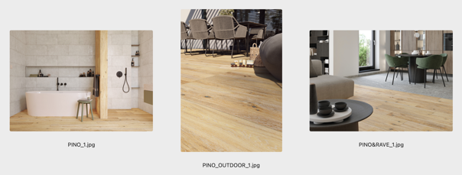

BLOSSOM: Ceramic artworks

BLOSSOM wall tiles are a botanical revolution - not only for the home. The floral collection combines extravagant style with a wow effect. The 30 x 90 cm rectified relief wall tiles become true works of art in bistros, reception areas or luxurious bathrooms. "Our idea was to develop a tile that creates a relaxed atmosphere and takes people out of their daily routine," explain RAKO's BLOSSOM designers. "The flowers and colours seem to break through the wall and let nature in."

BLOSSOM tile format:
30 x 90 cm

((Images: Please note copyright: RAKO, 2025))

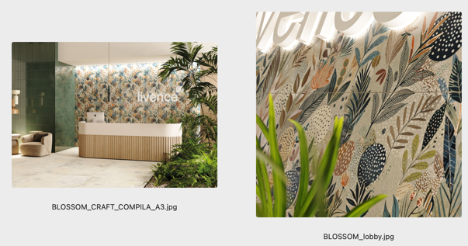

Press contact
Tim Westphal I Trade Press Relations I Communication I Consulting
Tel: +49 (0)30 80955821 • Mobile: +49 (0)172 9943665 - E: mail@timwestphal.de
Reprinting this press release is free of charge. In the event of publication, please send a file copy to the above press contact.

Company
LASSELSBERGER, s.r.o.
Adelova 2549/1 320 00
Plzeň - Jižní Předměstí
Czech Republic
info@rako.eu
www.rako.eu

LASSELSBERGER, s.r.o.
Adelova 2549/1 320 00
Plzeň - Jižní Předměstí
Czech Republic
info@rako.eu
www.rako.eu
LASSELSBERGER, s.r.o.
is a member of the LASSELSBERGER Group.

About the RAKO brand
LASSELSBERGER, s.r.o. is the only manufacturer of ceramic wall and floor tiles in the Czech Republic and is also one of the largest manufacturers of flooring materials in Europe. LASSELSBERGER, s.r.o. has been maintaining and developing the tradition of the Czech RAKO brand for more than 140 years. RAKO products are supplied to more than 90 countries on all continents, with the Czech tiles always meeting the high standards of quality and durability required worldwide.
RAKO products consist of 96% domestic raw materials of natural origin. The company's plants produce the tiles in an environmentally-friendly manner, thanks to significant investments in the modernisation and expansion of existing production facilities and the use of the latest technologies.

Would you like more information? Please contact us at: info@rako.euor mail@timwestphal.de.
info@rako.eu or mail@timwestphal.de.

